Appositive Phrase as a modifier

🔹 What Is Participial Phrase as a modifier?
# Source: AI Source: Provided by: [Data Path: Persons Table -> ID Column: 1, Name_En Column: Motasem Essam] -> From: [Chatgpt (GPT‑5 Mini)] on [8/7/2025]
An appositive phrase is a noun or noun phrase that renames or explains another noun or pronoun beside it.
It functions as a modifier by giving more information about a noun.

🔸 Structure:
# Source: AI Source: Provided by: [Data Path: Persons Table -> ID Column: 1, Name_En Column: Motasem Essam] -> From: [Chatgpt (GPT‑5 Mini)] on [8/7/2025]
[Appositive] + [Modifiers]
It often follows the noun it modifies, but it can also come before it.

🔸 Examples:
# Source: AI Source: Provided by: [Data Path: Persons Table -> ID Column: 1, Name_En Column: Motasem Essam] -> From: [Chatgpt (GPT‑5 Mini)] on [8/7/2025]
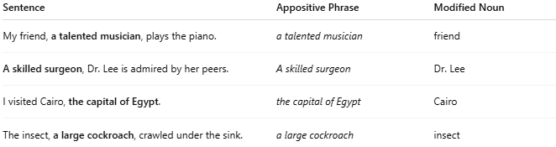
Sentence | Appositive Phrase | Modified Noun
My friend, a talented musician, plays the piano. | a talented musician | friend
A skilled surgeon, Dr. Lee is admired by her peers. | A skilled surgeon | Dr. Lee
I visited Cairo, the capital of Egypt. | the capital of Egypt | Cairo
The insect, a large cockroach, crawled under the sink. | a large cockroach | insect

🔸 Punctuation Rules:
# Source: AI Source: Provided by: [Data Path: Persons Table -> ID Column: 1, Name_En Column: Motasem Essam] -> From: [Chatgpt (GPT‑5 Mini)] on [8/7/2025]
- Nonessential appositives (not crucial for identification) are set off by commas.
→ My brother, an engineer, lives in New York.
- Essential appositives (crucial to meaning) are not set off by commas.
→ My friend Lisa is coming over.

🔸 Key Features:
# Source: AI Source: Provided by: [Data Path: Persons Table -> ID Column: 1, Name_En Column: Motasem Essam] -> From: [Chatgpt (GPT‑5 Mini)] on [8/7/2025]
- Always noun-based
- Adds detail or clarification to a noun
- Can be short (a teacher) or *longer phrases (an expert in ancient languages)

